**A review on β-glucan as a Prophetic medicine for health benefit**

**Samia Akter1, Anab Fatima2, Md. Moklesur Rahman Sarker1,3\***

*1Department of Pharmacy, State University of Bangladesh, 77 Satmasjid Road, Dhanmondi, Dhaka 1205, Bangladesh*

*2Department of Pharmaceutics, Dow College of Pharmacy, Dow University of Health Sciences, Karachi, Pakistan*

*3Health Med Science Research Network, 3/1 Block F, Lalmatia, Dhaka 1207, Bangladesh*

**\*Corresponding author:**

Md. Moklesur Rahman Sarker, PhD, Professor and Head of Academic & Research Affairs, Department of Pharmacy, State University of Bangladesh, 77 Satmasjid Road, Dhanmondi, Dhaka 1205, Bangladesh

Email: prof.moklesur@sub.edu.bd; moklesur2002@yahoo.com

Tel: +8801776758882

**Abstract**

β-glucan is a type of fiber (can be soluble or insoluble) which is classified as a naturally occurring polysaccharide. It is found in the cell walls of whole grains, seaweeds, mushrooms and yeast. Β-glucan is used as medicine and health supplement due to its health benefits as it can stimulate the immune system by modulating humoral and cellular immunity and thereby can help to fight infections caused by bacteria, virus, fungus and parasite. β-glucan also exhibits lipid lowering, hypocholesterolemic and anticoagulant properties. Recently, it has been found that β-glucan is anti-cytotoxic, antimutagenic and anti-tumorogenic. β-glucan is helpful in the diseases like chronic kidney diseases and cardiovascular diseases. These properties of β-glucan make it a promising candidate as a prophetic medicine for promotion of health. In the time of Prophet Muhammad (Peace be upon Him), prophetic medicine was developed. Prophetic medicine is the group of saying and act of prophet (Peace be upon Him) and focused on herbal lore, hygiene, dietary practices, exercise regimens. The present article discusses the evidence supporting the potential uses of β-glucan for health promotion and scope of it to be a prophetic medicine.

Keywords: β-glucan, Lipid lowering agent, hyperlipidemia, Prophetic medicine, Nutraceuticals

**Introduction**

Foods especially which have been used amongst the ancient society, have become a major interest for the scientist now a days. Therefore investigation has been started for finding the scientific values of the traditional medicinal plant. The evaluation of various properties of the functional foods which have some biologically active molecules is an important part of this kind of investigation. In recent years, whole grains or whole grains products such as beta-glucan have become a major field of research due to their numerous helpful propertiesl for promoting health.

Numerous epidemiological studies indicate that consumption of dietary fiber such as β-glucan can promote health as well as can be used to treat different types of disease (Wiebke & Michael, 2017). Recently, beta-glucan is turning into a licensed drug from non-specific immunomodulator due to its established uses in various disease conditions.

Polysaccharides including glucans have been described as biologically active molecules (Tzianabos, 2000; Ooi et al., 2000; Falch et al., 2000; Han et al., 1999). Certain glucose polymers, such as (1→3), (1→6)- β-glucans were recently proposed as potent immunomodulationg agents (Vaclav et al., 2018; Barsanti et al., 2011; Chan et al., 2009; Brown et al., 2005).

Glucan can be extracted from the cell walls of yeast, oat, barly, seaweeds, algae and bacteria. The foremost source of medical glucans turns out to be fungal cell walls which consist either of polysaccharides such as chitin, cellulose, (1→3), (1→6)- β-glucans and (1→3)-α-glucans or polysaccharide-protein complexes (Yap et al., 2001).

The β-glucans are the most studied polysaccharides and principally obtained from the fruit body of various types of mash rooms.

But as a health promoting factor, oat β-glucan mainly studied by the researcher. For this reason now-a-days oat β-glucan mainly termed as β-glucan. (Daou et al., 2012)

According to some scientific studies it is reported that beta-glucan can produce antitumor, immunomodulating, cardiovascular, antihypercholesterolemia, antiviral, antibacterial, antiparasitic, antifungal and antidiabetic effects (Vetvicka and Vetvickova, 2018; Novak and Vetvicka, 2017; Meng et al., 2016; Vetvicka and Vetvickova, 2015; Sima et al., 2015; Richter et al., 2014; Chen et al., 2013; Chang et al., 2012; Daou et al., 2012; Wasser, 2011; Shomori et al., 2009; Novak and Vetvicka, 2008; Vaclav et al., 2007; Bedirli et al., 2007). It is also found in some research that beta- glucan have potential effect on chronic kidney disease and cardiovascular diseases (Mohammad et al., 2016; Chen and Raymond, 2017; Daou et al., 2012, Queenan et al., 2007). The receptors of beta-glucan in various cells and the mechanism of action of it have recently been unfolded via in vitro and in vivo animal experiments (Vaclav et al., 2018; Chan, 2007). Therefore, β-glucan may be the best type of soluble fiber for improving health condition though further investigation is needed. As beta-glucan comes mainly from oat or barley or mushroom, it can be considered as a prophetic medicine like honey, black seeds, olive etc. The aim of the current review is to assess all the possible therapeutic properties of beta-glucan.

**Beta-glucan: Sources and Properties**

There are lots of sources from where beta-glucan can be obtained and isolated.

Β-glucan can be obtained from various species of mushrooms such as Reishi, Shiitake and Maitake (Selitrennikoff, 2001; Grun, 2001; Wasser and Weis, 1999).

It can also be obtained from some types of seaweed (Novak and Vetvicka, 2008; Teas, 1983, Black et al., 1951) and cereals (Daou et al., 2012; Basic et al., 2009, Cho, 2001).

In cereals, the content of β-glucan varies with environmental conditions during endosperm development and is regulated by (1 → 3, 1 → 4)-β-glucan endohydrolase to facilitate endosperm cell-wall degradation during germination (Stuart and Fincher, 1987). Among cereals, the highest content (g per 100 g dry weight) of β-glucan has been reported for barley: 2-20 g (water soluble fraction is 65%) and for oats: 3-8 g (water soluble fraction is 82%). Some other cereals also contain β-glucan but in much lower amounts: sorghum 1.1-6.2 g, rye 1.3-2.7 g, maize 0.8-1.7 g, triticale 0.3-1.2 g, wheat 0.5-1.0 g, durum wheat 0.5-0.6 g and rice 0.13 g (Basic et al., 2009).

Table 1: Sources of Beta-glucan.

|  |  |
| --- | --- |
| **Source Of Β-Glucans** | **Β-Glucans Structure** |
| *Saccharomyces cerevisiae* | Β-1,3-glucan |
| *Lentinus edodes* | β-1,3;1,6-glucan |
| Yeast | β-1,3;1,6-glucan |
| *Schizophyllan commune* | β-1,3;1,6-glucan |
| Seaweed | β-1,3;1,6-glucan |
| *Grifola frondosa* | β-1,3;1,6-glucan with xylose and mannose |
| *Coriolus versicolor* | Protein bound β-1,3;1,6-glucan |
| Cereals | Β-D-glucopyranose units linked through β-1,3;1,4 |
| *Ganoderma lucidum* | β-1,3;1,6-glucan |
| *Agaricus blazei* | Protein bound β-1,6-glucan |
| *Pleurotus ostreatus* | β-1,3-glucan with galactose and mannose |
| *Coprinus comatus* | β-1,3-glucan |

The glucans are D-glucose based polysaccharides. They can be α-D-glucans, β-D-glucans and mixed α,β-D-glucans with their glucose anomeric structure. Glucans can be homoglucans or heteroglucans. Homoglucans are those having only glucose molecules in their structure, when they have any other molecule besides glucose molecule are called heteroglucans (Synytsya et al., 2013).

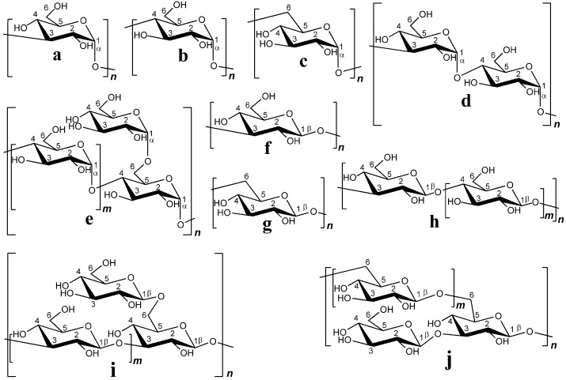

Figure-1 : Structure of Fungal glucans: (a) (1→3)-α-D-glucan; (b) (1→4)-α-D-glucan; (c) (1→6)-α-D-glucan; (d) mixed linkage (1→3), (1→4)-α-D-glucan; (e) branched (1→4), (1→6)-α-D-glucan; (f) (1→3)-β-D-glucan; (g) (1→6)-β-D-glucan; (h) mixed- linkage (1→3), (1→4)-β-D-glucan; (i) branched (1→3), (1→6)-β-D-glucan; (j) branched (1→6), (1→3)-β-D-glucan.

The β-glucans consist of linear unbranched polysaccharides of β-D-glucose. The basic β-D-glucan is a repeating β-D-glucose units joined together in linear chains by β-bonds. These can be extend either from carbon 1 of one saccharide ring to carbon 3 of the next (β1→3) (Figure- 2) or from carbon 1 to carbon 4 (β→4) or from carbon 1 to carbon 6 (β1→6) (Tzianabos, 2000). The β-D-glucans may have up to 250,000 glucose units (Luca et al., 2013).

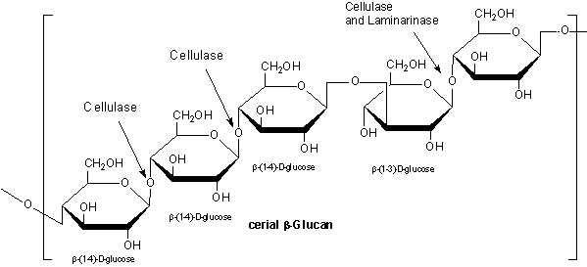

Figure-2: Cereal β-glucan.

**Immunostimulatory and wound healing properties of glucans**

In the initial studies, it has been found that β-D-glucans increase the resistance of mammalian cells against some pathogens including bacteria, virus, fungus and protozoa (Kaneko et al., 1992). A study compared the effects of soluble oat glucan versus Pleurotan, an insoluble β-D-glucan isolated from the mushroom *Pleurotus ostreatus.* They were administered as a food supplement for athletes. β-D-glucan which is from mushroom significantly reduces the incidence of upper respiratory tract infection whereas Pleurotan increases the number of circulating natural killer cells as well as a preventive effect on the reduction of natural killer cell activity (Majtan J, 2013). In many studies, it has been found that (1→3)-β-D-glucan activates innate immunity with effects on adaptive immunity inducing humoral and cell-mediated immune responses. They also increase antimicrobial activity of mononuclear cells and neutrophils and enhance the functional activity of macrophages (Chanput et al., 2012; Murphy et al., 2008, Novak & Vetvicka, 2008). The overall effect of β-glucan on Immunity is summarized in the schematic diagram (Figure-3):

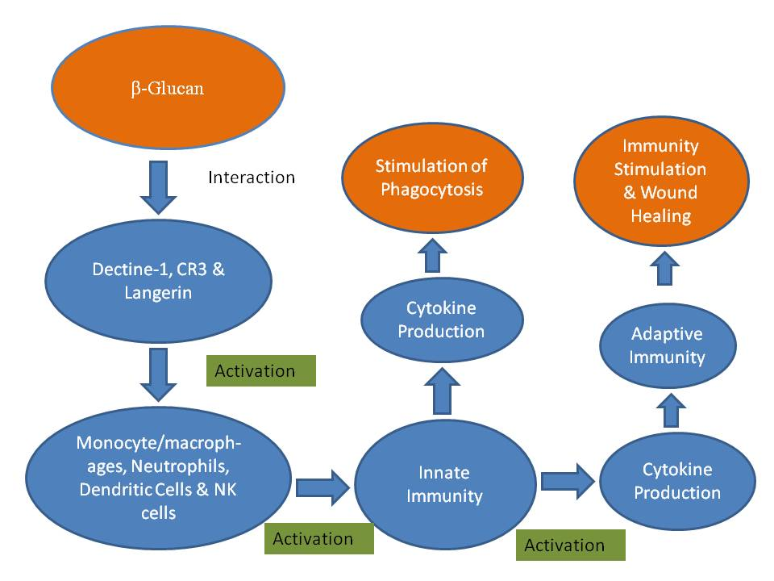

Figure-3: Immunostimulation & Wound Healing Properties of β-glucan. Β-glucan interacts with dectin-1, complement receptor type 3 and langerin. These interaction individually activate either or combinely neutrophile, macrophages and natural killer cells. And thus results in stimulation of immunity and wound healing. For the immunostimulating effect of β-glucan, it can be good alternative for antibiotic agents.

**Lipid Lowering Properties**

Over the past several decades, it has been believed that β-glucan can reduce cholesterol level by its lipid lowering activities but not fully understood.

According to some scientific research, β-glucan has strong cholesterol and triglyceride lowering properties leading to reduced cardiovascular disease. Adding β-glucan in diet reduced LDL (Low density lipoprotein) and total cholesterol without changing HDL (High Density lipoprotein) and triglycerides (Whitehead et al., 2017; AbuMweis et al., 2010).

The main mechanism for β-glucan’s lipid lowering effect is thought to be dependent on its ability to entrap whole micelles containing bile acid in the intestinal contents with the luminal membrane transporters on the intestinal epithelium, thereby the absorption or reabsorption of cholesterol decreases (Ellegard et al., 2007; Theuwissen and Mensink, 2008). As a result, hepatic conversion of cholesterol into bile acid increases and hepatic pools of free cholesterol decreases. Along with an increasing synthesis of endogenous cholesterol, the activities of 7α-hydroxylase and HMGCoA reductase increase to compensate for the loses of bile acid and cholesterol from liver. Furthermore, hepatic LDL-cholesterol receptors become unregulated which lead to decreased serum LDL-cholesterol concentration (Jeon and Blacklow 2005; Ellegard et al., 2007).

Foretz et al., 2018 described that the energy sensor AMP-activated protein kinase i.e. AMPK phosphorylate and inhibited Acetyl CoA carboxylase (ACC) which results in the inhibition of de novo lipogenesis and stimulation of Fatty acid oxidation (FAO). Finally lowers the Triglycerides content [Figure-4 (a)]. Hypothetical mechanism of Lipid lowering activities of β-glucan is demonstrated in the Figure-4 (b):

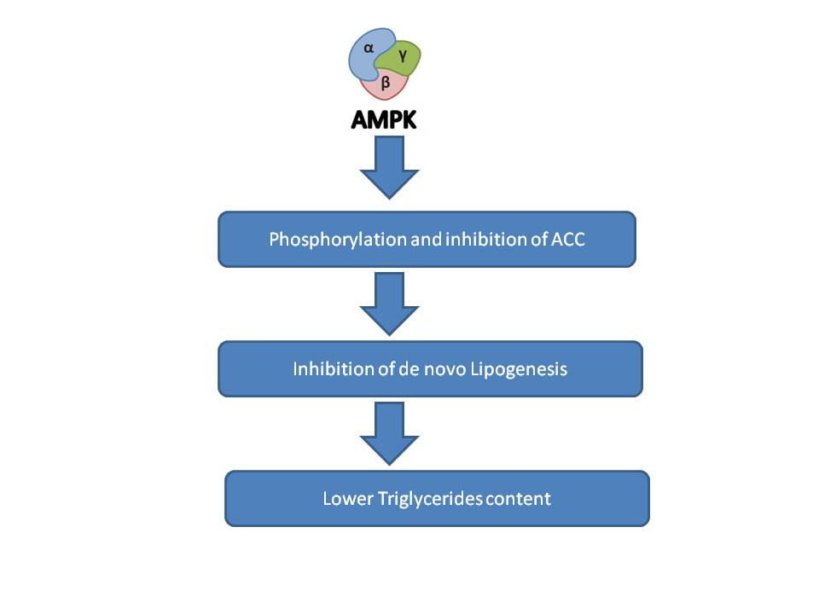

**Figure-4 (a): Function of AMPK in lipid lowering.**

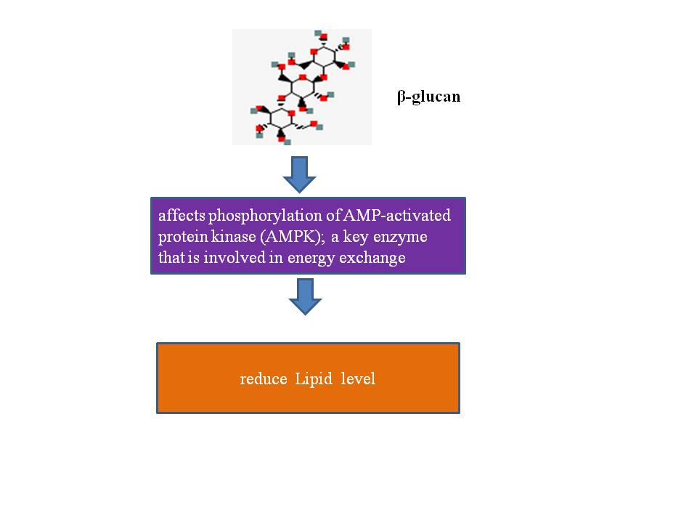**Figure-4 (b): Lipid lowering properties of β-glucan.**

**Antidiabetic Properties**

Fibers are beneficial for the lowering of blood glucose level. Β-glucan being a soluble fiber modifies the properties of chime in stomach affecting gastric emptying, gut motility and nutrient absorption with viscous characteristics of it (Behall et al., 2006). It is found that oat β-glucan intake is beneficial in type-2 diabetes (Charles, 2005).

Wood and others (1994, 2000, and 2007) suggested that the reductions in glucose and insulin responses after a meal are mainly due to the viscosity caused by oats. They studied mixtures of oat beta-glucans with different viscosity and there was a highly significant linear relationship between the viscosity and the glucose and insulin responses.

Tapola and others (2005), in their study “glycemic responses of oat bran products in type-2 diabetic patients,” also concluded the same when they studied volunteers with type-2 diabetes fed on oat bran flour, oat bran crisp, and a glucose load providing 12.5 g glycemic carbohydrate and 25 g glucose load alone, and 25 g glucose load with 30 g oat bran flour. In both series oat bran products rapidly lowered postprandial glucose concentrations than after the 12.5 g or 25 g glucose load during the 1st hour, but the glucose concentration was greater at 120 min after the oat bran products ingestion than after the glucose load. This decrease of glucose absorption will decrease insulin release and thereby attenuate pancreatic insulin response. Therefore, oat β-glucan has a greater effect at lowering peak glucose absorption concurrently with an attenuated insulin response, which has a high significance in control and prevention of type-2 diabetes (Hooda and others 2010). It was noted that the area under the plasma glucose curve (AUC) for the postprandial period after ingestion of the oat bran crisp was larger than the AUC after the oat bran flour. This means oat bran flour lowered more rapidly the postprandial glucose response than oat bran crisp. As explanation, the β-glucan content of oat bran flour is higher than oat bran crisp and the authors concluded that oat bran flour being high in β-glucan had a low-glycemic response and acted as an active ingredient, decreasing the postprandial glycemic response of an oral glucose load in subjects with type2-diabetes (Tapola and others 2005). Another test was carried on healthy volunteers who were given 4 different test meals: without added cereal fibers and enriched with 10 g cereal fibers (wheat bran, oat bran, and a combination of 5 g of each). The postprandial glucose and insulin responses were similar as previously (Juvonen and others 2011).

The effect on glucose metabolism of long-term intake of oat beta-glucan has also been investigated. An intake of oat beta-glucan (3 g in muesli) taken for breakfast for 4 wk in men with type 2-diabetes led to a decreased cholesterol level and lower postprandial glucose peaks but no effects on fasting plasma glucose, insulin, and HbA1c were observed (Kabir and others 2002). Researchers have shown that obesity is one of the causes of type 2-diabetes. In the United States of America obesity affects approximately 9 million children over 6 y of age. This dramatic rise in childhood obesity has led to a predicted risk of between 30%–40% for children born in 2000 who will be diagnosed with noninsulindependent diabetes mellitus (NIDDM or Type 2-diabetes) during their lifetime (Koplan and others 2005).Dietary fiber intake helps to decrease the prevalence of obesity. Howarth and others (2001) have reported that an increase in either soluble or insoluble fiber could play a key role in obesity control. Fiber intake increases postmeal satiety and decreases subsequent hunger. Then, the consumption of an additional 14 g/d fiber for >2 d is associated with a 10% decrease in energy intake and body weight loss of 1.9 kg over 3 mo, and obese individuals may even exhibit a greater suppression of energy intake. Slavin (2005) also reported strong epidemiologic support that dietary fiber intake prevents obesity and that fiber intake is inversely associated with body weight and body fat. The amount of fiber intake by adults that may help to decrease the prevalence of obesity should be >25 g/d (Howarth 2001).

**Anti-cancer properties**

Several in vitro studies demonstrated that β-glucan has anti-mutagenic effect. Β-glucan obtained from barley has protective effect against damage caused by methyl methanesulfonate (MMS), in the CHO-K1 cell line. In this study, β-glucan extracted from *Saccharomyces cerevisiae* was found to have an effect on the cell lines CHO-K1 and CHO-xrs5 in which these cell lines were found protected against damage caused by MMS (Oliveira et al., 2006). This β-glucan was also found to have a protective effect against genotoxicity and cytotoxicity when administered with drugs such as cyclophosphamide, adriamycin and cisplatin. This protective effect may be due to the entrapment of free radicals produced during the biotransformation of these drugs (Tohamy et al., 2003). Along with protective effect, β-glucan has potential anti-oxidant effect as it prevents damage by H2O2 and other reactive oxygen species (Krizkova et al., 2006; Slamenova et al., 2003; Angeli et al., 2006).

Some studies have demonstrated that fungal β-glucans can act as chemopreventive agents as they can inhibit isozymes of cytochrome P450 family which are involved in the activation of carcinogens such as benzo [a]pyrene (Hashimoto et al., 2002).

Some studies demonstrate that β-glucans have no direct cytotoxic effects (Chan et al., 2009). One study, it was said that β-glucan only stimulates the proliferation of monocytic lineage leukemic cells in vitro and facilitate the maturation of dendritic cells derived from leukemic cells (Chan et al., 2008).

Β-glucan as an anti-oxidant and immunomodulatory agent is much more therapeutically accepted than cytotoxic agent (Sener et al., 2006). Β-glucan is believed to increase anticancer activities of monoclonal antibodies in cancer therapy (Cheung et al., 2002).

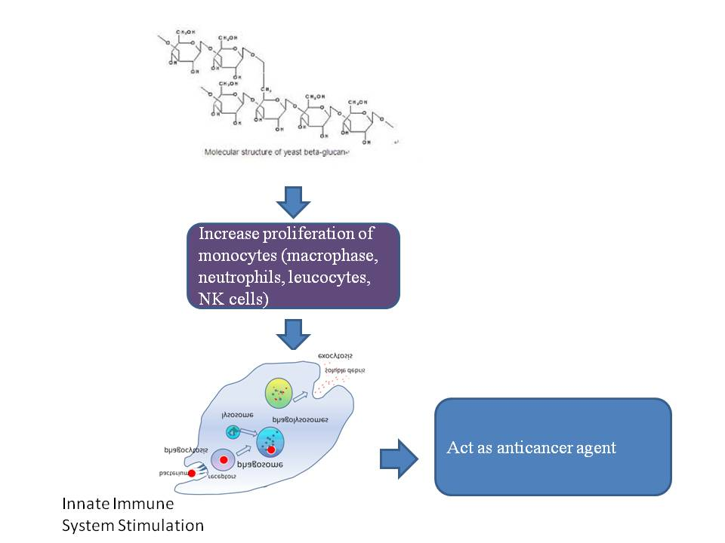

Figure-5: β-glucan as anticancer agent.

**Effect on Chronic kidney disease**

Some animal studies reported that β-glucan intake has positive effect on kidney function but this effect was not assessed in humans (Rouhani et al., 2016; Esrefoglu et al., 2016). But as β-glucan lower the cholesterol level in the human body, it is be helpful for patients of chronic kidney disease who has gone through hemodialysis. A study has been conducted on it (Liang et al., 2015). On this study, it is concluded that β-glucan improve the inflammatory and malnutrition condition in hemodialysis patient. However, further researches have been suggested to study thoroughly about the effect on overall chronic kidney disease. Another research have demonstrated that β-glucan have positive effect on renal ischemia and reperfusion injury (Esrefoglu et al., 2016). According to that study the mechanism is shown in figure-6.

In where, it is described that as antioxidant agent, β-qglucan reduce the level of IL-6 and IL-8 which are primarily responsible for ischemia.

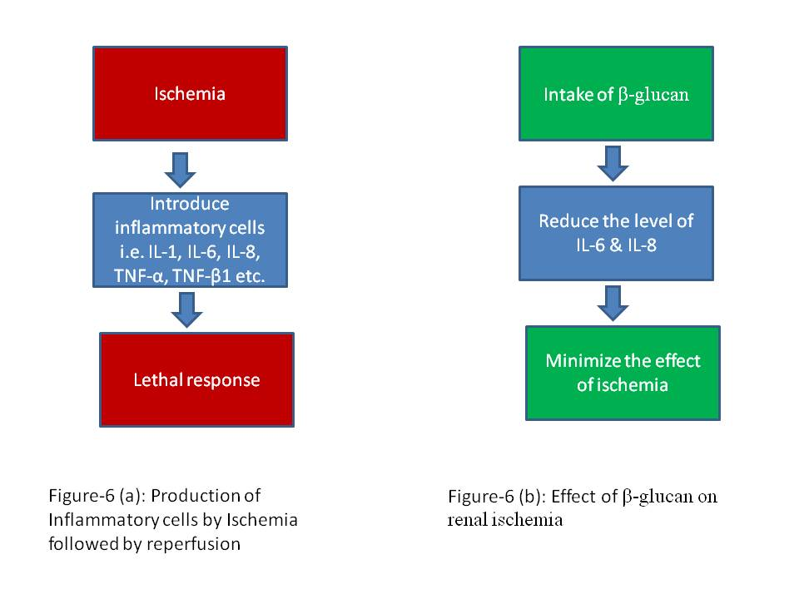

Further investigations are required for getting complete data on the effect of β-glucan on chronic kidney disease.

**Effect on Cardiovascular diseases**

Β-glucan reduce the total cholesterol along with LDL cholesterol as a result the occurrences of heart disease reduced by 20% (Medscape news, 2000). It also reduces hypertension (Maki et al., 2007). In many researches, it has been studied experimentally that β-glucan effectively can reduce blood LDL as well as cholesterol and ApoB level. These three factors combinely results in a positive effect on cardiovascular disease as well as hypertension (Hoang et al., 2016).

The brief mechanism of action of β-glucan in reduction of cardiovascular disease is shown below:

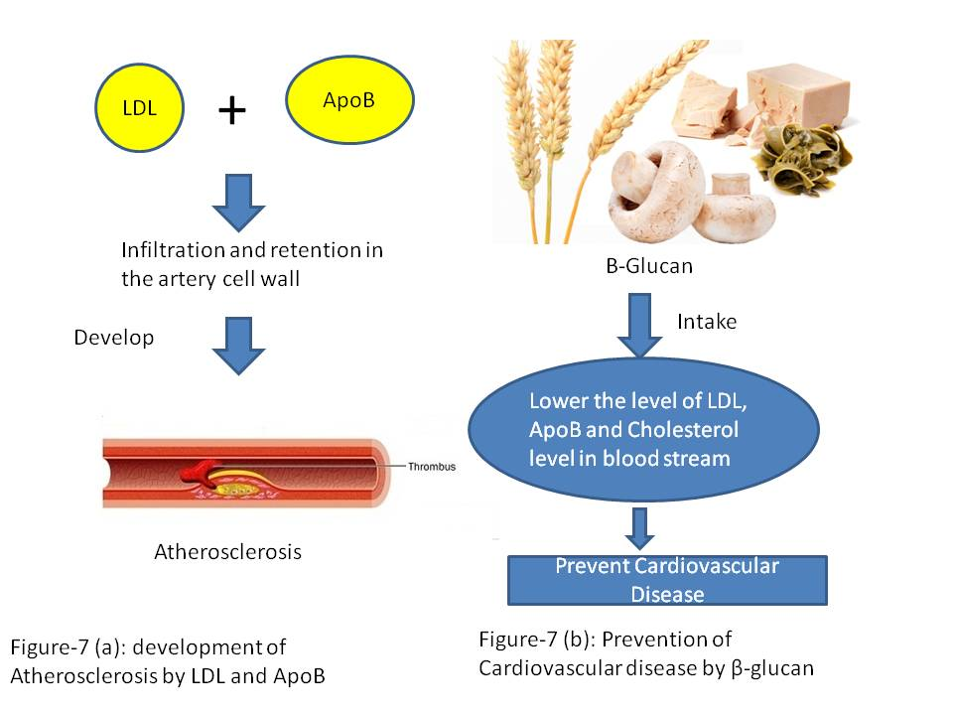

Low Density Lipoprotein (LDL) and Apolipoprotein (ApoB) directly stimulates the atherosclerosis in the coronary artery. Their infiltration and retention in the artery wall results in the inflammation and injury in the artery cell wall and further internalization of Apolipoprotein by macrophages promotes foam cell (hallmark of the fatty steak phase of atherosclerosis) formation. The inflammation of macrophage subsequently results in the formation of stable fibrous barrier i.e. plaque formation in the artery wall (Linton et al., 2019). Intake of β-glucan reduces the LDL cholesterol and ApoB level in the blood thus prevents the incidence of cardiovascular disease.

**Conclusion and Potentiality**

Β-glucan has so many biological activities regardless of its origin. Β-glucan have immunostimulating, lipoid lowering, antitumor effect as well as it is very useful in cardiovascular and chronic kidney diseases.

These findings make it as very good candidate as a prophetic medicine. As there is a less amount of data for human trial for all the possible properties of β-glucan, it is very much needful to do much more investigation in human to get more accurate data for future use of β-glucan. It may then be considered as an alternative for chemotherapy as well as antibiotic, antidiabetic and antihypertensive agents.

**References**

A.A. Tohamy, A.A. El-Gohr, S.M. El-Nahas, M.M. Noshy, b-Glucan inhibits the genotoxicity of cyclophosphamide, adramycin and cisplatin, Mutat. Res. 541 (2003) 45–53.

Anderson TJ, Gregoire J, Hegele RA, et al. (2013) 2012 update of the Canadian Cardiovascular Society guidelines for the diagnosis and treatment of dyslipidemia for the prevention of cardiovascular disease in the adult. Can J Cardiol 29, 151–167.

Anne Whitehead, Eleanor J Beck, Susan Tosh, and Thomas MS Wolever. Cholesterol-lowering effects of oat b-glucan: a meta-analysis of randomized controlled trials, 2017

Asim Abdelmoneim Hussein, MD, Mohamed Ali Albar, Saud Mohamed Alsanad, Prophetic Medicine, Islamic Medicine, Traditional Arabic and Islamic Medicine (TAIM): Revisiting Concepts & Definitions. International Journal of Biological & Medical Research. 2018;9(3):6460-6465

Bacic A, Fincher GB, Stone BA. Chemistry, Biochemistry, and Biology of (1-3)-[beta]-Glucans and Related Polysaccharides. 1st edition. Amsterdam, The Netherlands: Academic Press; 2009.

Barsanti L, Passarelli V, Evangelista V, Frassanito AM and Gualtieri P: Chemistry, physico-chemistry and applications linked to biological activities of β-glucans. Nat Prod Rep 28: 457-466, 2011.

Beck EJ, Tapsell LC, Batterham MJ, et al. (2010) Oat betaglucan supplementation does not enhance the effectiveness of an energy-restricted diet in overweight women. Br J Nutr 103, 1212–1222.

Bedirli A, Kerem M, Pasaoglu H, Akyurek N, Tezcaner T, Elbeg S, Memis L and Sakrak O: Beta-glucan attenuates inflammatory cytokine release and prevents acute lung injury in an experimental model of sepsis. Shock 27(4): 397-401, 2007.

Behall KM, Scholfield DJ, Hallfrisch JG. 2006. Barley b-glucan reduces plasma glucose and insulin responses compared with resistant starch in men. Nutr Res 26:644–50.

Beta-Glucan Key to Cardiovascular Health Benefits - Medscape - May 02, 2000.

Black, W. A. P., Cornhill, W. J., Dewar, E. T., and Woodward, F. N. 1951. Manufacture of algal chemicals. III. Laboratory scale isolation of laminarin from brown marine algae. J. Appl. Chem. 1:505–507.

Browder W, Williams D, Lucore P, et al. 1988. Effect of enhanced macrophage function on early wound healing. Surgery, 104:224–30.

Brown GD and Gordon S: Immune recognition. A new receptor for beta‑glucans. Nature 413: 36‑37, 2001.

Brown GD, Gordon S: Immune recognition of fungal-glucans. Cell Microbiol 2005, 7:471–479.

Chan GC, Chan WK and Sze DM: The effects of beta-glucan on human immune and cancer cells. J Hematol Oncol 2: 25, 2009.

Chan GC, Chan WK, Sze DM: The effects of beta-glucan on human immune and cancer cells. J Hematol Oncol 2009, 2:25.

Chan WK, Law HK, Lin ZB, Lau YL, Chan GC: Response of human dendritic cells to different immunomodulatory polysaccharides derived from mushroom and barley. Int

Chang ST and Wasser S: The role of culinary-medicinal mushrooms on human welfare with a pyramid model for human health. Int J Med Mushr 14: 95-134, 2012.

Chanput W, Reitsma M, Kleinjans L, Mes JJ, Savelkoul HF and Wichers HJ: β-glucans are involved in immune-modulation of THP-1 macrophages. Mol Nutr Food Res 56: 822-833, 2012.

Charles SB. 2005. Dietary fiber, glycemic response, and diabetes. Mol Nutr Food Res 49:560–70.

Cheickna Daou and Hui Zhang, Oat Beta-Glucan: Its Role in Health Promotion and Prevention of Disease. Immunol 2007, 19(7):891-899.

Chen SN, Nan FH, Chen S, Wu JF, Lu CL, Soni MG. 2011. Safety assessment of mushroom β-lucan: subchronic toxicity in rodents and mutagenicity studies. Food Chem Toxicol 49(11):2890–8.

Chen Y, Dong L, Weng D, Liu F, Song L, Li C, Tang W and Chen J: 1,3-beta-glucan affects the balance of th1/th2 cytokines by promoting secretion of anti-inflammatory cytokines in vitro. Mol Med Rep 8(2): 708-712, 2013.

Cheung NKV, Modak S, Vickers A, Knuckles B. 2002. Orally administrered β-glucans enhance anti-tumor effects of monoclonal antibodies. Cancer Immunol Immunother 51 (10):557–64.

Cho SS. 2001. Handbook of dietary fiber. New York: Marcel Dekker, Inc. 868 p.

D. Chorvatovicova´, Suppressing effects of glucan on micromuceli induced by Co60 in mice, Stranhlenther Onkol. 167 (1991)612–614.

D. Slamenova´, J. La´baj, L. Krizkova´, G. Kogan, J. Sandula, N.Bresgen, P. Eckl, Protective effects of fungal b-D-glucan derivatives against oxidative DNA lesions in V79 hamster lung cells, Cancer Lett. 198 (2003) 153–160.

Demir G, Klein HO, Mandel-Molinas N and Tuzuner N: Beta glucan induces proliferation and activation of monocytes in peripheral blood of patients with advanced breast cancer. Int Immunopharmacol 7(1): 113-116, 2007.

Ellegard L, Andersson H. 2007. Oat bran rapidly increases bile acid excretion and bile acid synthesis: an ileostomy study. Eur J Clin Nutr 61:938–45.

Esrefoglu M, Tok OE, Aydin MS, Iraz M, Ozer OF, Selek S, Iraz M. Effects of beta-glucan on protection of young and aged rats from renal ischemia and reperfusion injury. Bratisl Med J 2016; 117 (9). 541 – 549

Falch BH, Espevik T, Ryan L and Stokke BT: The cytokine stimulating activity of (1→3)-beta-D-glucans is dependent on the triple helix conformation. Carbohydr Res 329: 587-596, 2000.

Food and Drug Administration (2009) Labeling & Nutrition: Guidance for Industry: Evidence-Based Review System for the Scientific Evaluation of Health Claims - Final. http://www.fda.gov/Food/GuidanceRegulation/GuidanceDocuments RegulatoryInformation/LabelingNutrition/ucm073332.htm.

Geraldine F Keogh Garth JS Cooper Tom B Mulvey Brian H McArdle Graeme D Coles John A Monro Sally D Poppitt. 2003. Randomized controlled crossover study of the effect of a highly β-glucan–enriched barley on cardiovascular disease risk factors in mildly hypercholesterolemic men. The American Journal of Clinical Nutrition, Volume 78, Issue 4, October 2003, Pages 711–718.

Godfrey Chi-Fung Chan, Wing Keung Chan and Daniel Man-Yuen Sze, The effects of β-glucan on human immune and cancer cells.Journal of Hematology & Oncology, 2009 2:25

Goodridge HS, Wolf AJ and Underhill DM: Beta-glucan recognition by the innate immune system. Immunol Rev 230: 38-50, 2009.

Gr¨un, C. H. (Ed.) 2001. Structure and Biosynthesis of Fungal α-Glucans. Proef. Univer.: Utrecht, the Netherlands.

Han SB, Lee CW, Jeon YJ, Hong ND, Yoo ID, Yang KH and Kim HM: The inhibitory effect of polysaccharides isolated from Phellinus liteus on tumor growth and metastasis. Immunopharmacology 41: 157-164, 1999.

Hoang V. T. Ho, John L. Sievenpiper, Andreea Zurbau, Sonia Blanco Mejia, Elena Jovanovski, Fei Au-Yeung, Alexandra L. Jenkins and Vladimir Vuksan. 2016. The effect of oat β-glucan on LDL-cholesterol, non-HDL-cholesterol and apoB for CVD risk reduction: a systematic review and meta-analysis of randomised-controlled trials. British Journal of Nutrition (2016), 116, 1369–1382.

Hofer M and Pospíšil M: Modulation of animal and human hematopoiesis by β-glucans: a review. Molecules 16: 7969-7979, 2011

Howarth NC, Saltzman E, Roberts SB. 2001. Dietary fiber and weight regulation. Nutr Rev 59(5):129–39.

J.P.F. Angeli, L.R. Ribeiro, M.F. Bellini, M.S. Mantovani, Anticlastogenic effect of beta-glucan extracted from barley towards chemically induced DNA damage in rodent cells, Hum. Exp. Toxicol. 25 (2006) 319–324.

Jeon H, Blacklow SC. 2005. Structure and physiologic function of the low-density lipoprotein receptor. Annu Rev Biochem 74:535–62.

Jiezhong Chen and Kenneth Raymond: Beta-glucans in the treatment of diabetes and associated cardiovascular risks, 2017

Johansson L, Virkki L, Anttila H, Esselstr¨om H, Tuomainen P, Sontag-Strohm T. 2006. Hydrolysis of β-glucan. Food Chem 97:71–9.

Johansson L, Virkki L, Mannus S, Letho M, Ekholm P, Varo P. 2000. Structural characterization of water soluble β-glucan of oat bran. Carbohydr Polym 42:143–8.

Juvonen KR, Salmenkallio-Marttila M, Lyly M, Liukkonen K-H, L¨ahteenm¨aki L, Laaksonen DE, Uusitupa MI, Herzig KH, Poutanen KS, Karhunen LJ. 2011. Semisolid meal enriched in oat bran decreases plasma glucose and insulin levels, but does not change gastrointestinal peptide responses or short-term appetite in healthy subjects. Nutr Metab Cardiovasc Dis 21(9):748–56.

Kabir M, Oppert J-M, Vidal H, Bruzzo F, Fiquet C, Wu`e Rsch P, Slama G, Rizkalla SW. 2002. Four-week low-glycemic index breakfast with a modest amount of soluble fibers in type 2-diabetic men. Metabolism 51(7): 819–26.

Kaneko Y and Chihara G: Potentiation of host resistance against microbal infections by lentinan and its related polysaccharides. In: Microbal Infections: Role of Biological Response Modifers. Friedman H, Klein TW and Yamaguchi H (eds). Plenum Press, New York, NY, pp201-215, 1992.

Kenyon AJ, Michaels EB. 1983. Modulation of early cellular events in wound healing in mice. Am J Vet Res, 44:340–3.

L. Krizkova, I. Zitnanova, D. Mislovicova, J. Masarova, V.Sasinkova, Z. Durackova, J. Krajcovica, Antioxidant and antimutagenic activity of mannan neoglycoconjugates: mannan–human serum albumin and mannan–penicillin G acylase, Mutat.Res. 606 (2006) 72–79.

Legentil L, Paris F, Ballet C, Trouvelot S, Daire X, Vetvicka V and Ferrières V: Molecular interactions of β‑(1→>3)‑glucans with their receptors. Molecules 20: 9745‑9766, 2015

Liang-Min Xie, Yi-Yun Ge, Xin Huang, Yi-Qiong Zhang, Jun-Xuan Li.2015. Effects of fermentable dietary fiber supplementation on oxidative and inflammatory status in hemodialysis patients. Int J Clin Exp Med 2015;8(1):1363-1369.

Luca Vannucci, Jiri Krizan , Petr Sima , Dmitry Stakheev , Fabian Caja , Lenka Rajsiglova , Vratislav Horak And Mustafa Saieh : Immunostimulatory properties and antitumor activities of glucans, 2013

MacRae F Linton, MD, Patricia G Yancey, PhD, Sean S Davies, PhD, W. Gray Jerome, PhD, Edward F Linton, MD, Wenliang L Song, MD, Amanda C Doran, PhD, MD, and Kasey C Vickers, PhD. The Role of Lipids and Lipoproteins in Atherosclerosis. NCBI Bookshelf. A service of the National Library of Medicine, National Institutes of Health. 2019

Majtan J: Pleuran (β-Glucan from Pleurotus ostreatus): an effective nutritional supplement against upper respiratory tract infections? Med Sport Sci 59: 57-61, 2013.

Maki KC, Galant R, Samuel P, et al. Effects of consuming foods containing oat beta-glucan on blood pressure, carbohydrate metabolism and biomarkers of oxidative stress in men and women with elevated blood pressure. Eur J Clin Nutr. 2007;61:786–95.

[Marc Foretz](https://www.ncbi.nlm.nih.gov/pubmed/?term=Foretz%20M%5BAuthor%5D&cauthor=true&cauthor_uid=30235785), [Patrick C. Even](https://www.ncbi.nlm.nih.gov/pubmed/?term=Even%20PC%5BAuthor%5D&cauthor=true&cauthor_uid=30235785) and [Benoit Viollet](https://www.ncbi.nlm.nih.gov/pubmed/?term=Viollet%20B%5BAuthor%5D&cauthor=true&cauthor_uid=30235785). AMPK Activation Reduces Hepatic Lipid Content by Increasing Fat Oxidation *In Vivo.* International Journals of Molecular Science. V. 19(9). 2018 (PMID: [30235785](https://www.ncbi.nlm.nih.gov/pubmed/30235785)).

Meng X, Liang H and Luo L: Antitumor polysaccharides from mushrooms: A review on the structural characteristics, antitumor mechanisms and immunomodulating activities. Carbohydr Res 424: 30-41, 2016

Ministry of Health Malaysia (2014) Malaysian dietary guidelines — Key Message 14 — make effective use of nutrition information on food labels. Putrajaya, Malaysia: Ministry of Health Malaysia. www.moh.gov.my/images/gallery/Garispanduan/diet/km14.pdf (accessed November 2014).

Mohammad Hossein Rouhani , Mojgan Mortazavi Najafabadi , Pamela J. Surkan , Ahmad Esmaillzadeh ,Awat Feizi , Leila Azadbakht: The impact of oat (Avena sativa) consumption on biomarkers of renal function in patients with chronic kidney disease: A parallel randomized clinical trial, 2016

Mohammad Hossein Rouhani , Mojgan Mortazavi Najafabadi , Pamela J. Surkan , Ahmad Esmaillzadeh , The impact of oat (Avena sativa) consumption on biomarkers of renal function in patients with chronic kidney disease: A parallel randomized clinical trial, European Society for Clinical Nutrition and Metabolism. 2016

Moher D, Liberati A, Tetzlaff J, et al. (2009) Preferred reporting items for systematic reviews and meta-analyses: the PRISMA statement. PLoS Med 6, e1000097.

Murphy EA, Davis JM, Carmichael MD, Gangemi JD, Ghaffar A, Mayer EP. 2008. Exercise stress increases susceptibility to influenza infection. Brain Behav Immun 22:1152–5.

National Cholesterol Education Program (NCEP) Expert Panel (2002) Third report on detection, evaluation, and treatment of high blood cholesterol in adults (Adult Treatment Panel III) final report. Circulation 106, 3143–3421.

Novak M and Vetvicka V: Beta‑glucans, history, and the present: Immunomodulatory aspects and mechanisms of action. J Immunotoxicol 5: 47‑57, 2008.

Novak M and Vetvicka V: From hyperthermia to immunomodulating polysaccharides. Am J Immunol 13(1): 11-18, 2017.

Olson BH, Anderson SM, Becker MP. Psyllium-enriched cereals lower blood total cholesterol and LDL-cholesterol but not HDL-cholesterol in hyper-cholesterolemic adults: results of a meta-analysis. J Nutr 1997;127:1973–80

Ooi VE and Liu F: Immunomodulation and anticancer activity of polysaccharide-protein complex. Curr Med Chem 7: 715-729, 2000.

Panahi S (2006) The effect of oat beta-glucan on glycemia and blood lipid risk factors for cardiovascular disease. Thesis, University of Toronto.

Queenan KM, Stewart ML, Smith KN, Thomas W, Fulcher RG and Slavin JL. Concentrated oat beta-glucan, a fermentable fiber, lowers serum cholesterol in hypercholesterolemic adults in a randomized controlled trial. Nutr J 2007; 6: 6

R.J. Oliveira, L.R. Ribeiro, A.F. Silva, R. Matuo, M.S. Mantovani, Evaluation of antimutagenic activity and mechanisms of action of b-glucan from barley, in CHO-K1 and HTC cell lines using the micronucleus test, Toxicol. In Vitro 20 (2006) 1225–1233.

Richter J, Svozil V, Kral V, Rajnohova Dobiasova L, StiborovaI and Vetvicka V: Clinical trials of yeast-derived beta-(1,3)glucan in children: Effects on innate immunity. Ann Transl Med 2(2): 15-20, 2014.

Ross GD and Vĕtvicka V: CR3 (CD 11b. CD 18): A phagocyte and NK cell membrane receptor with multiple ligand specificities and functions. Cell Exp Immunol 92: 181‑184, 1993

Saenger A (2011) Cardiovascular Risk Assessment Beyond LDL Cholesterol: Non-HDL Cholesterol, LDL Particle Number, and Apolipoprotein B. Mayo Clinic Communique. http://www.mayomedicallaboratories.com/articles/communique/2011/ 11.html (accessed April 2015).

Selijelid R, Bogwald J, Rasmussen LT, Larm O, Hoffman J, Berge A and Ugelstad J: In vivo activation of mouse macro- phages with beta-1,3-D-glucan-derivatized plastic beads. Scand J Immunol 6: 601-605, 1985.

Selitrennikoff, C. P. 2001. Antifungal proteins. Appl. Environ. Microbiol.67:2883–2894.

Shomori K, Yamamoto M, Arifuku I, Teramachi K and Ito H: Antitumor effects of a water-soluble extract from maitake (grifola frondosa) on human gastric cancer cell lines. Oncol Rep 22(3): 615-620, 2009.

Sima P, Vannucci L and Vetvicka V: Glucan and cancer: Historical prospective. Canc Transl Med 1(6): 209-214, 2015.

S S AbuMweis, S Jew & N P Ames. β-glucan from barley and its lipid-lowering capacity:a meta-analysis of randomized, controlled trials, 2010

Stuart IM, Loi L, Fincher GB. Immunological comparison of (1-3,1-4)-beta-glucan endohydrolases in germinating cereals. Journal of Cereal Science. 1987;6(1):45–52.

Synytsya A and Novák M: Structural diversity of fungal glucans. Carbohydr Polym 92: 792-809, 2013.

T. Hashimoto, Y. Nonaka, K. Minato, Suppressive effect of polysaccharides from the edible and medicinal mushrooms, Lentinus edodes and Agaricus blazei, on the expression of cytochrome P450s in mice, Biosci. Biotechnol. Biochem. 344(2002) 610–1614.

Tapola N, Harvonen H, Niskamen L, Mikola M, Sarkkinen. 2005. Glycemic responses of oat bran products in type 2-diabetic patients. Nutr Metab Cardiovasc Dis 15:255–61.

Teas J. The dietary intake of Laminaria, a brown seaweed, and breast cancer prevention. Nutrition and Cancer. 1983;4(3):217–222.

The Board of Food Standards Australia New Zealand (2013) Food Standards, Vol. 1.2.7: Nutrition, Health and Related Claims. Canberra: Commonwealth of Australia.

The Cochrane Collaboration (2011) Cochrane Handbook for Systematic Reviews of Interventions Version 5.1.0 [J Higgins and S Green, editors]. www.cochrane-handbook.org

Theuwissen E, Mensink RP. 2008. Water-soluble dietary fibers and cardiovascular disease-a review. Physiology & Behavior 94(2):285–92.

Tzianabos A: Polysaccharide immunomodulators as therapeutic agents: structural aspects and biologic function. Clin Microbiol Rev 13: 523-533, 2000.

Usui S, Tomono Y, Sakai M, Kiho T and Ukai S: Preparation and antitumor activities of beta-(1→6) branched (1→3)-beta-D-glucan derivatives. Biol Pharm Bull 18: 1630-1636, 1995.

Vaclav Vetvicka and Jana Vetvickova: Glucans and cancer: Comperison of commercially available β-glucans- Part IV. Anticancer research 38: 1327-1333, 2018

Vetvicka V and Vetvickova J: Glucan supplementation has strong anti-melanoma effects:

Role of .. cells. Anticancer Res 35(10): 5287-5292, 2015.

Vetvicka V, Dvorak B, Vetvickova J, Richter J, Krizan J, Sima P and Yvin JC: Orally administered marine (1-->3)-beta-d-glucan phycarine stimulates both humoral and cellular immunity. Int J Biol Macromol 40(4): 291-298, 2007.

Volman JJ, Ramakers JD and Plat J: Dietary modulation of immune function by beta-glucans. Physiol Behav 94: 276-284, 2008.

Wakshull E, Brunke-Reese D, Lindermuth J, Fisette L, Nathans RS, Crowley JJ, Tufts JC, Zimmerman J, Mackin W and Adams DS: PGG-glucan, a soluble beta-(1,3)-glucan, enhances the oxidative burst response, microbicidal activity and activates an NF-kappa B-like factor in human PMN: evidence for a glycosphingolipid beta-(1,3)-glucan receptor. Immunopharmacology 41: 89-107, 1999.

Wasser SP, Weis AL. Therapeutic effects of substances occurring in higher basidiomycetes mushrooms: a modern perspective. Critical Reviews in Immunology. 1999;19(1):65–96

Wasser SP: Current findings, future trends and unsolved problems in studies of medicinal mushrooms. Appl Microbiol Biotechnol 89: 1323-1332, 2011.

Whitehead A, Beck EJ, Tosh S, et al. (2014) Cholesterollowering effects of oat beta-glucan: a meta-analysis of randomized controlled trials. Am J Clin Nutr 100, 1413–1421.

Wiebke Schlörmann & Michael Glei: Potential health benefits of β-glucan from barley and oat. Ernaehrungs Umschau international | 10/2017.

Williams DL, Ha T, Li C, Laffan J, Kalbfleisch J and Browder W: Inhibition of LPS‑induced NFkappaB activation by a glucan ligand involves down‑regulation of IKKbeta kinase activity and altered phosphorylation and degradation of IkappaBalpha. Shock 13: 446‑452, 2000

Wolever TM, Tosh SM, Gibbs AL, et al. (2010) Physicochemical properties of oat β-glucan influence its ability to reduce serum LDL cholesterol in humans: a randomized clinical trial. Am J Clin Nutr 92, 723–732.

Wood PJ, Beer MU, Butler G. 2000. Evaluation of the role of concentration and molecular weight of oat β-glucan in determining effect of viscosity on plasma glucose and insulin following an oral glucose load. Br J Nutr 84:19–23.

Wood PJ, Braaten JT, Scott FW, Riedel KD, Wolynetz MS, Collins MW. 1994. Effect of dose and modification of viscous properties of oat gum on plasma glucose and insulin following an oral glucose load. Br J Nutr 72:731–43.

Wood PJ, Siddiqui IJ, Paton D. 1978. Extracting of high-viscosity gums from oats. Cereal Chem 55:1038–49.

Wood PJ, Weisz J, Blackwell BA. 1991. Molecular characterization of cereal β-glucans. Structural analysis of oat β-glucan and rapid structural evaluation of β-glucans from different sources by high-performance liquid chromatography of oligosaccharides released by lichenase. Cereal Chem 68:31–9.

Wood PJ. 2007. Cereal β-glucans in diet and health. J Cereal Sci 46:230–8.

Xia Y, Vetvicka V, Yan J, Hanikyrová M, Mayadas T and Ross GD: The beta‑glucan‑binding lectin site of mouse CR3 (CD 11b/CD 18) and its function in generating a primed state of the receptor that mediates cytotoxic activation in response to iC3b‑opsonized target cells. J Immunol 162: 2281‑2290, 1999.

Xiang D, Sharma VR, Freter CE and Yan J: Anti-tumor monoclonal antibodies in conjunction with beta-glucans: A novel anti-cancer immunotherapy. Curr Med Chem 19(25): 4298-4305, 2012.

Yap AT and Ng ML: An improved method for the isolation of lentina from the edible and medicinal shiitake mushroom, Lentinus edodes (Berk.) Sing. (Agaricomycetideae). Int J Med Mushr 3: 6-19, 2001.