F:\F Drive-14 April 2019\HEALTH MED SCIENCE RES LTD\HMS RESEARCH NETWORK\logo.png

**Healthmed Journal of Pharmaceutical Sciences**

Journal Homepage: http://ps.healthmedsci.org/

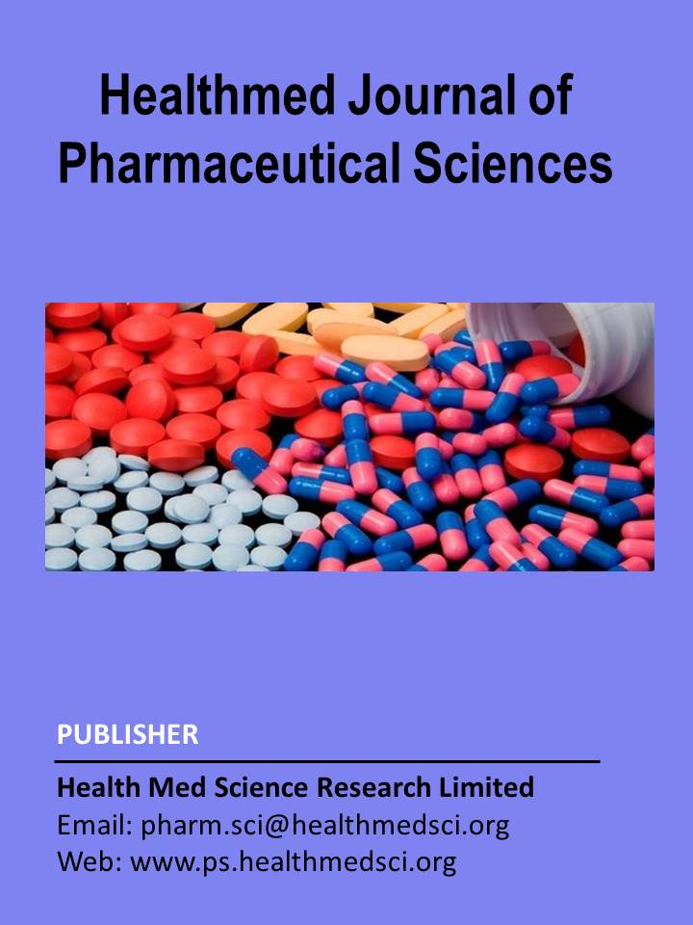

**Research Article**

**Combination Chemotheraphy for Cancer Treatment: a cross-sectional study on Bangladeshi people at NICRH**

Shahenul Islam1*, Md Shahin Alam1, Tasnim Jahan2, Md. Kamrul Hasan3, A. F. M. Mahmudul Islam4,Md. Sabbir Hossain5

1Department of Pharmacy, Dhaka International University, Satarkul, Badda, Dhaka-1212, Bangladesh;

2Department of English, Dhaka International University, Satarkul, Badda, Dhaka-1212, Bangladesh;

3Department of Management, Government Rajendra College, Faridpur, Faridpur Sadar-7800, Bangladesh;

4Department of Pharmacy, Gono University (Bishwabidyalay), Nolam, Mirzanagar, Savar, Dhaka- 1344, Bangladesh;

5Department of Clinical Pharmacy and Pharmacology, Faculty of Pharmacy, University of Dhaka, Dhaka-1000, Bangladesh;

### Abstract

The chemotherapy is to cure cancer; to reduce recurrence after surgery or adjuvant therapy; to control cancer by reducing symptoms or palliative chemotherapy. Mostly cancer treatments are based on selective killing of the cancer cells but not normal cells but now it is a well-known that normal cells are also damaged by chemotherapeutic drugs, which leads to various side effects and in some cases even death. So, there is a need of novel cancer treatment approach, which specifically reduces the tumor with minimum or no side effects. One solution to enhancing conventional chemotherapy efficacy and reducing its side effects is modifying the drug delivery system and discovering more efficient target drugs. An ideal drug delivery system must deliver drugs only to cancer sites and sustain high, stable drug concentrations. Based on the scientific literature, this review discusses the current and future applications of pharmacogenomics in clinical cancer therapy and cancer drug development in treating different cancers. This study may pose an interesting pharmacophore suitable for lead generation for managing different cancers by combination chemotheraphy. Since the report reviews the current state of affairs on the effectiveness of chemotherapy in treating cancer, more research is desperately needed.

**Keywords**: Chemotheraphy, Cancer, Pharmacogenomics, Socio-demographic status

**\* Correspondence:** Name **(**Shahenul Islam), Designation (Lecturer), Affiliation (Department of Pharmacy, Dhaka International University, Satarkul, Badda, Dhaka-1212, Bangladesh); Email: [diptoshahen@gmail.com](mailto:diptoshahen@gmail.com); Phone: +8801820997383

# Introduction

# Cancer is a group of diseases involving abnormal cell growth with the potential to invade or spread to other parts of the body.[1] Not all tumors are cancerous; benign tumors do not spread to other parts of the body. Cancer is a generic term for a large group of diseases that can affect any part of the body. Other terms used are malignant tumours and neoplasms. One defining feature of cancer is the rapid creation of abnormal cells that grow beyond their usual boundaries, and which can then invade adjoining parts of the body and spread to other organs; the latter process is referred to as metastasis. Widespread metastases are the primary cause of death from cancer. Cancer is a leading cause of death worldwide, accounting for nearly 10 million deaths in 2022, or nearly one in six deaths. In the past 20 years, from 2001 to 2022, cancer death rates went down 27%, from 196.5 to 144.1 deaths per 100,000 population. The highest cancer rate for men and women combined was in Denmark at 334.9 people per 100,000. The age-standardized rate was at least 300 per 100,000 for 10 countries: Denmark, Ireland, Belgium, Hungary, France, The Netherlands, Australia, Norway, France (New Caledonia) and Slovenia. International Agency for Research on Cancer has estimated cancer-related death rates in Bangladesh to be 7.5% in 2005 and 13% in 2030. And the most common cancers are breast, lung, colon and rectum and prostate cancers. Around one-third of deaths from cancer are due to tobacco use, high body mass index, alcohol consumption, low fruit and vegetable intake, and lack of physical activity. Cancer causing infections, such as human papillomavirus (HPV) and hepatitis, are responsible for approximately 30% of cancer cases in low- and lower-middle-income countries. Many cancers can be cured if detected early and treated effectively.

# Chemotherapeutic drugs have a narrow therapeutic index and the dosage needed to achieve a therapeutic response usually proves toxic to the body’s rapidly proliferating cells. The duration of the study was only for six months, a major limitation of the study. The number of patients developing the ADRs was also less. So, similar studies covering more patients from different regions are needed to validate the findings of this study. We view the interactions between normal and cancer cells as being competitive for available resources, and we think of the chemotherapy agent as a predator on both normal and cancer cells. cancer treatment by chemotherapy where there is metastasis from a primary to a secondary site by the cancer cells. Progressive muscle relaxation training was used to reduce the conditioned negative responses developed by a 30-yr-old cancer patient undergoing chemotherapy treatment. that included Baseline, Phase 1,2 therapist-directed relaxation and Phase 2 patient-directed relaxation sessions, the patient underwent therapist-directed or self-directed relaxation training immediately before and during 10 consecutive chemotherapy treatments.

# The importance of chemotherapy for cure of cancer is increasing, especially with its use as adjuvants to local therapy. Furthermore, in advanced disease, when the tumor has disseminated from its place of origin, chemotherapy has an expanding role in efforts to relieve cancer-related symptoms and to prolong life. Despite its shortcomings, chemotherapy, therefore, is an important treatment modality in oncology and will probably remain so for considerable time 3 Chemotherapy has already proven widely effective in the treatment of certain malignancies (childhood ALL, CML, Hodgkin disease, choriocarcinoma, testicular cancer, etc.) occupying a prominent place in the current therapeutic arsenal. However, for other cancers (e.g. pancreas, melanoma, NSCLC, liver, etc.) there has been a plateau in the evolution of the results that we try to explain in this critical analysis. This survey does not show a clear survival benefit from the use of induction chemotherapy prior to radiotherapy, surgery or CRT. MCT is currently prescribed by Oncologists in different types of malignancies, mostly outside a clinical trial and after failure of at least two previous lines of treatment in stage II colon cancer management, surgery alone has shown a high cure rate (about 80%), and the role of adjuvant chemotherapy is still a matter of debate.

# Rationale of Cancer Chemotherapy:

# Chemotherapy is an aggressive form of chemical drug therapy meant to destroy rapidly growing cells in the body. It’s usually used to treat cancer, as cancer cells grow and divide faster than other cells. Chemotherapy is often used in combination with other therapies, such as surgery, radiation, or hormone therapy. Chemotherapy is primarily used to lower the total number of cancer cells in your body, reduce the likelihood of cancer spreading, shrink tumor size, reduce current symptoms. Side effects of chemotherapy include: easy bruising and excessive bleeding, diarrhea, dry mouth, mouth sores, fatigue, fever, hair loss, loss of appetite, nausea, vomiting, weight loss, pain from nerve damage, infections, anemia, constipation, neuropathy, lymphedema, memory problems, concentration problems, skin changes, nail changes, insomnia, sexual changes, fertility changes. The effectiveness of chemotherapy may depend on several factors, including the type of cancer a person has, how early a doctor catches it, and which treatment regimen the person and their treatment team select. In some cases, however, chemotherapy can only prolong a person’s life, not save it.

# Materials and Methods

# Study design: This is a qualitative study that used framework analysis to examine in-depth interviews among hospitalized patients. From these the survey was accomplished in National Institute of Cancer Research & hospital (NICRH), Dhaka, Bangladesh. During the recruitment period there were 100+ individuals in the hospital studied both indoor and outdoor.

**Study site:** National Institute of Cancer Research & Hospital, Dhaka, Bangladesh

**Study duration:** 10th January 2024 to 20th November 2024

**Inclusion & Exclusion criteria:** The criteria for choosing those hospital: **t**he hospitals have well established and full set up for diagnosis and treatment for cancer patients**, t**he patients of those hospitals come from various regions and represent different socioeconomic status for that there was a greater possibility to get good variation diseases among them**,** Patients are familiar with or have basic knowledge of diseases. Based on the foregoing criteria, the identified project sites include those hospitals.

# Data collection procedure: A pre-coded questionnaire was developed to obtain relevant information regarding socio-demographic status such as age, weight, gender, marital status, education, disease which type of drugs are taken, chemotherapy patients or not, Effectiveness of chemotherapy, cancer in the family or not, outdoor food habit etc. The questionnaire was pre-tested before finalization. The primary data was collected from the field. To collect the data, the interview schedule techniques were used. The advantages of these techniques are: a face-to-face data collection, less time and money consumer, more scientific, less factual error.

# Purpose of the Project: You are being asked to be a volunteer or patients under investigation in a pharmacogenetics study involving the collection of your information will be used in the study. The purpose of this study is to characterize the genotypes of cancer in Bangladeshi peoples, which will be helpful for the adjustment of dosage regimen, reduce the serious adverse reactions to ensure safe, effective and economic treatment.

# Volunteer Consent Form:

# Patient or control identification for this study:

# You are being asked to participate in a clinical study. Your decision to take part in this study is strictly voluntary and you are under no obligation to participate. If you decide not to participate or if you choose to withdraw after beginning the study, you will not lose any benefits associated with your medical care. You are encouraged to ask questions before deciding whether you wish to participate as volunteer during this research work. Your identity will be kept confidential throughout the study. The research staff will use only a coded number, access will be limited to authorized scientists and any scientific publications, lectures or reports resulting from the study will not identify participant by name.

### Results

#### Sex Ratio:

Among the 100 prescriptions- male patients 47 % and female patients 53 %

**Age Distribution:**

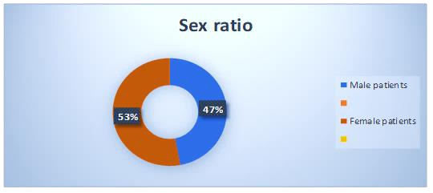

Among the prescription the highest number of patients 45% were between (31- 50) years of age, 27% patients were between (51-60) years of Age, 20% patients were between (61-80) years of age and 8% patients were between (10-30) years of age.

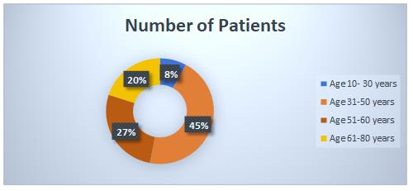

#### Disease Variation:

Among the prescription the highest number of diseases is Lung Cancer where 17% of 100 patients. 16% of disease is Breast cancer, 15% were Ovarian cancer, 9% were the Rectal & Colon Cancer, 8% will be the Laryngeal cancer & Buccal Mucosa than Cervix cancer, Intestinal & Esophageal Cancer and Throught or Mouth cancer will be the 4% of patients in these diseases, last one is the Gall bladder cancer is only 3%.

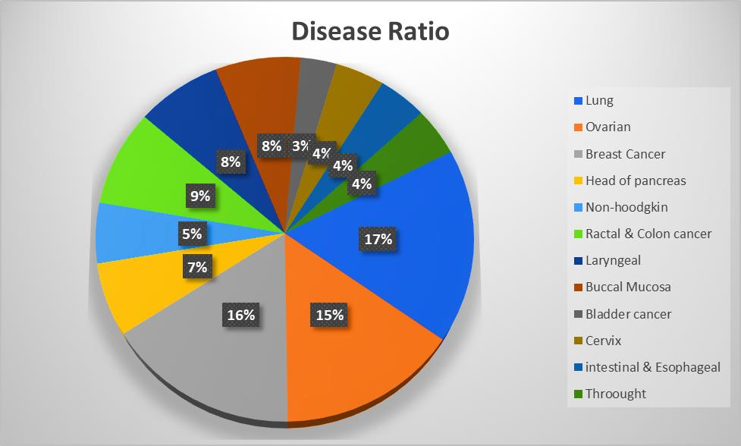

#### Chemotherapeutic Drug Ratio:

Among the prescription the highest number of Chemotherapy drug is Cisplatin where the 25% & 18% of Chemotherapy drug is Paclitaxel, 16% were the Gemicitabine & Filgrastine. 11% of the Chemotherapy drug is 5-florouracil, 5% will be the carboplatine & cyclophosphomide chemotherapeutic drug, 3% will be the Docetexel, last one is the zoledonic acid only 1%

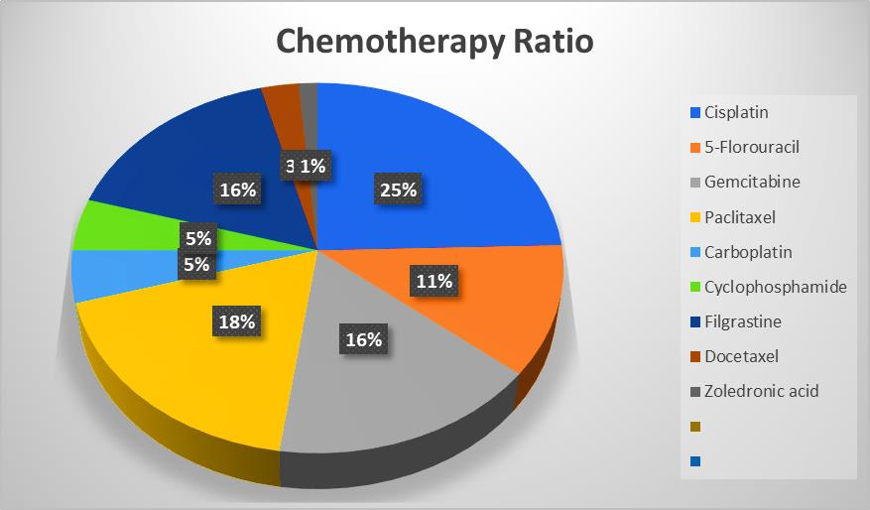

**Weight Variation**:

Among the prescription the highest number of patients, 71% of weight between (30- 50) Kg & 29% of weight were between (51-75) Kg.

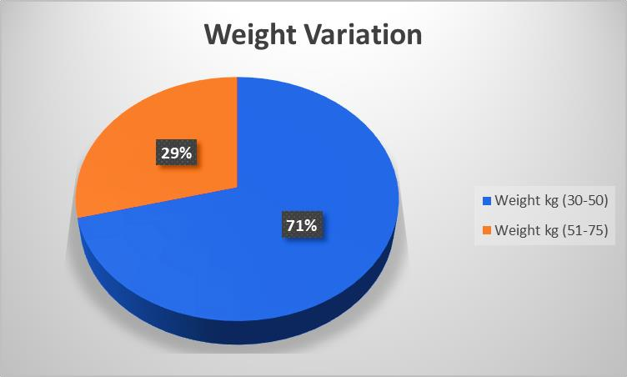

### Discussion

To model the impact of reimbursement generosity on a patient’s likelihood of chemotherapy treatment, we used probit regressions with provider-specific random effects. Our models include year-indicator variables to control for national trends in treatment patterns.

Methods and materials are necessary for assessment, analysis, and determination of causes of the cancer diseases. A pre-coded questionnaire was developed to obtain relevant information regarding socio-demographic status such as age, weight, gender, marital status, education, disease, which type of drugs are taken, chemotherapy patients or not, Effectiveness of chemotherapy, cancer in the family or not, outdoor food habit etc. The questionnaire was pre-tested before finalization.

We visited hospital, which is located in the Dhaka district for the collection of data from the patient. This is a qualitative study that used framework analysis to examine in-depth interviews among hospitalized patients. From these, the survey was accomplished in National Institute of Cancer Research & hospital (NICRH), Dhaka, Bangladesh.

Analysis showed that the number of enrolled participants is Among the 100 prescriptions- male patients 47 % and female patients 53%. Among the prescription the highest number of patients 45% persons were between (31- 50) years of age, 27% patients were between (51-60) years of Age, 20% patients were between (61-80) years of Age, and 8% patients were between (10-30) years of Age.

Then, we compared the distribution of the disease variation were among 100 patients of the prescription. The highest number of diseases is Lung Cancer where 17% of patients. 16% of disease is Breast cancer, 15% were Ovarian cancer, 9% were the Rectal & Colon Cancer, 8% will be the Laryngeal cancer & Buccal Mucosa, then Cervix cancer, Intestinal & Esophageal Cancer and Throught or Mouth cancer will be the 4% of patients in this disease, last one is the Gall bladder cancer comprising only 3%.

Chemotherapeutic Drug Ratio will be the highest number of Chemotherapy drug is Cisplatin where the 25% & Than 18% of Chemotherapy drug is Paclitaxel, 16% were the Gemicitabine & Filgrastine, 11% were the Chemotherapy drug 5-florouracil, 5% will be the Carboplatine & Cyclophosphamide Chemotherapeutic drug, then 3% will be the Docetexel, last one is the Zoledonic acid only 1%. Combination chemotherapy refers to the use of two or more drugs to treat cancer. The aim is to attack cancer cells using different mechanisms and to reduce the chance of the cancer developing resistance to any one drug. Combination chemotherapy can be used to treat a wide range of cancers, including breast cancer, lung cancer and leukemia.

##### Commonly used chemotherapy drugs include: Platinum-based drugs, such as cisplatin and carboplatin; Taxanes such as paclitaxel and docetaxel; Anthracyclines, such as doxorubicin and epirubicin; Alkylating agents, such as cyclophosphamide and ifosfamide; Antimetabolites, such as fluorouracil and methotrexate; Vinca alkaloids, such as vincristine and vinblastine. In this study, we investigated the association with different variables and cancer susceptibility. The purpose of this study is to characterize the genotypes of cancer in Bangladeshi peoples, which will be helpful for the adjustment of dosage regimen, reduce the serious adverse reactions to ensure safe, effective and economic treatment. The effectiveness of combinational chemotherapy may depend on several factors, including the type of cancer a person has, how early a doctor catches it, and which treatment regimen the person and their treatment team select. In some cases, however, chemotherapy can only prolong a person’s life, not save it.

### Conclusion

### understanding of the genetic bases for interindividual differences in drug effect has the potential to significantly enhance the efficacy of chemotherapeutic agents. Moreover, such information may allow

### for rational selection of chemotherapy agents and optimization of dosing regimens for individual cancer patients. One solution to enhance conventional chemotherapy efficacy and reduce its side effects is modifying the drug delivery system and discovering more efficient target drugs. An ideal complex drug should target all cancer cells, and not normal cells; a multifunctional Nano carrier can meet both demands. Given cancer stem cell hierarchy complexity, a strategy involving combination therapy should be used to target both the bulk of differentiated cancer cells and the minority of cancer stem cells together. The bulk of stable cancer cells are indispensable for testing drug effects in the search for more efficient drugs that target cancer cells. The four Cancer stem cell enrichment methods described earlier are phenotypic isolation of cancer cells with specific cancer stem cell markers, conventional cytotoxic chemotherapy or radiotherapy, suspension cultivation, and EMT. A high-throughput screening platform may be a better choice for screening efficient target drugs. Learning from cancer stem cells, combining new drug delivery systems, and new target drugs may reveal novel strategies for chemotherapy in the future.

### List of Abbreviations

NICRH: National Institute of Cancer Research & Hospital, NSCLC: Non-small cell lung cancer, CML: Chronic myelogenous leukemia, EMT: Epithelial–mesenchymal transition

### Conflicts of Interest

The authors declare that the research was conducted in the absence of any commercial or financial relationships that could be construed as a potential conflict of interest.

**Author Contributions Statement**

Conceptualization: Shahenul Islam, Md. Shahin Alam; Data curation: Md Shahin Alam, Shahenul Islam, A.F.M. Mahmudul Islam; Formal analysis: Shahenul Islam, Md. Sabbir Hossain; Investigation: Md. Shahin Alam, Shahenul Islam; Methodology: Shahenul Islam, Md Shahin Alam; Project administration: Md. Shahin Alam; Referencing: Shahenul Islam ; Resources: Tasnim Jahan, Md. Kamrul Hasan; Software: Tasnim Jahan, Md. Kamrul Hasan, A.F.M. Mahmudul Islam; Supervision: Shahenul Islam; Visualization: Tasnim Jahan, Shahenul Islam; Writing – original draft: Md. Shahin Alam, Shahenul Islam ; Writing – review & editing: Md. Shahin Alam, Shahenul Islam, Md. Sabbir Hossain, Tasnim Jahan, Md. Kamrul Hasan

**Funding Information**

# This research received no external funding.

**Acknowledgements**

Authors would like to thank to all the participants who contributed to the studies with their prescriptions and other information.

# Data Availability Statement

Data relevant to the study is already included to the article or attached in the supplements. Raw data will be provided on reasonable request upon contacting with the corresponding.

**References**

1. Antman, K.H., 2001. Introduction: the history of arsenic trioxide in cancer therapy. *The oncologist*, *6*(S2), pp.1-2.

1. Seyfried, T.N. and Shelton, L.M., 2010. Cancer as a metabolic disease. Nutrition & metabolism, 7, pp.1-22.
2. Johnson, D.G. and Walker, C.L., 1999. Cyclins and cell cycle checkpoints. Annual review of pharmacology and toxicology, 39.
3. Weinberg, R.A., 1996. How cancer arises. Scientific American, 275(3), pp.62-70.
4. Espina, V. and Liotta, L.A., 2011. What is the malignant nature of human ductal carcinoma in situ?. Nature Reviews Cancer, 11(1), pp.68-75.
5. Hoadley, K.A., Yau, C., Wolf, D.M., Cherniack, A.D., Tamborero, D., Ng, S., Leiserson, M.D., Niu, B., McLellan, M.D., Uzunangelov, V. and Zhang, J., 2014. Multiplatform analysis of 12 cancer types reveals molecular classification within and across tissues of origin. Cell, 158(4), pp.929-944.
6. Di Donato, V., Bellati, F., Fischetti, M., Plotti, F., Perniola, G. and Panici, P.B., 2012. Vaginal cancer. Critical reviews in oncology/hematology, 81(3), pp.286-295.
7. McDonald, D.M. and Baluk, P., 2002. Significance of blood vessel leakiness in cancer.
8. Schorge, J.O., McCann, C. and Del Carmen, M.G., 2010. Surgical debulking of ovarian cancer: what difference does it make?. Reviews in obstetrics and gynecology, 3(3), p.111.
9. Papillomavirus, H., 2019. and Cervical Cancer. World Health Organization Fact Sheet, World Health Organization, 24.
10. Blackadar, C.B., 2016. Historical review of the causes of cancer. World journal of clinical oncology, 7(1), p.54.
11. Sawicki, T., Ruszkowska, M., Danielewicz, A., Niedźwiedzka, E., Arłukowicz, T. and Przybyłowicz, K.E., 2021. A review of colorectal cancer in terms of epidemiology, risk factors, development, symptoms and diagnosis. Cancers, 13(9), p.2025.
12. Gilreath, J.A., Stenehjem, D.D. and Rodgers, G.M., 2014. Diagnosis and treatment of cancer‐ related anemia. American journal of hematology, 89(2), pp.203-212.
13. Penders, J., Fiers, T. and Delanghe, J.R., 2002. Quantitative evaluation of urinalysis test strips. Clinical chemistry, 48(12), pp.2236-2241.
14. Raab, S.S., Grzybicki, D.M., Vrbin, C.M. and Geisinger, K.R., 2007. Urine cytology discrepancies: frequency, causes, and outcomes. American journal of clinical pathology, 127(6), pp.946-953.
15. Parker, S.H., Stavros, A.T. and Dennis, M.A., 1995. Needle biopsy techniques. Radiologic Clinics of North America, 33(6), pp.1171-1186.
16. Duffy, M.J., 2007. Role of tumor markers in patients with solid cancers: a critical review. European journal of internal medicine, 18(3), pp.175-184.
17. Sudhakar, A., 2009. History of cancer, ancient and modern treatment methods. Journal of cancer science & therapy, 1(2), p.1.
18. Coffey, J.C., Wang, J.H., Smith, M.J.F., Bouchier-Hayes, D., Cotter, T.G. and Redmond, H.P., 2003. Excisional surgery for cancer cure: therapy at a cost. The lancet oncology, 4(12), pp.760- 768.
19. Baskar, R., Lee, K.A., Yeo, R. and Yeoh, K.W., 2012. Cancer and radiation therapy: current advances and future directions. International journal of medical sciences, 9(3), p.193.
20. Drãgãnescu, M. and Carmocan, C., 2017. Hormone therapy in breast cancer. Chirurgia, 112(4), pp.413-417.
21. Andrykowski, M.A. and Hunt, J.W., 1993. Positive psychosocial adjustment in potential bone marrow transplant recipients: Cancer as a psychosocial transition. Psycho‐Oncology, 2(4), pp.261- 276.
22. Joensuu, H., 2008. Systemic chemotherapy for cancer: from weapon to treatment. The lancet oncology, 9(3), p.304.
23. Joensuu, H., 2008. Systemic chemotherapy for cancer: from weapon to treatment. The lancet oncology, 9(3), p.304.
24. DeVita Jr, V.T. and Chu, E., 2008. A history of cancer chemotherapy. Cancer research, 68(21), pp.8643-8653.
25. Takemoto, M., et al. "The effect of various chemotherapeutic agents given with mild hyperthermia on different types of tumours." International journal of hyperthermia 19.2 (2003): 193-203.
26. Martin, R. and Teo, K.L., 1994. Optimal control of drug administration in cancer chemotherapy. World Scientific.
27. Kawamori, Y., 1971. Advantages and disadvantages of chemotherapy and changing features of infection. [Kango gijutsu]:[Nursing technique], 17(7), pp.9-15.
28. Ralhan, R. and Kaur, J., 2007. Alkylating agents and cancer therapy. Expert Opinion on Therapeutic Patents, 17(9), pp.1061-1075.
29. Loehrer, P.J. and EINHORN, L.H., 1984. Cisplatin. Annals of internal medicine, 100(5), pp.704-713.
30. van der Vijgh, W.J., 1991. Clinical pharmacokinetics of carboplatin. Clinical pharmacokinetics, 21(4), pp.242-261.
31. Lévi, F., Metzger, G., Massari, C. and Milano, G., 2000. Oxaliplatin: pharmacokinetics and chronopharmacological aspects. Clinical pharmacokinetics, 38, pp.1-21.
32. Sinoway, P.A. and Callen, J.P., 1993. Chlorambucil. Arthritis & Rheumatism: Official Journal of the American College of Rheumatology, 36(3), pp.319-324.
33. Bagley Jr, C.M., Bostick, F.W. and DeVita Jr, V.T., 1973. Clinical pharmacology of cyclophosphamide. Cancer Research, 33(2), pp.226-233.
34. Heard, B.E. and Cooke, R.A., 1968. Busulphan. Thorax, 23(2), pp.187-193.
35. Tew, K.D. and Schein, P.S., 1984. Nitrosoureas. Antitumor Drug Resistance, pp.425-442.
36. Fleming, A.B. and Saltzman, W.M., 2002. Pharmacokinetics of the carmustine implant. Clinical pharmacokinetics, 41, pp.403-419.
37. Allegra, C.J., Grem, J.L., Yeh, G.C. and Chabner, B.A., 1988. Antimetabolites. Cancer chemotherapy and biological response modifiers, 10, pp.1-22.
38. Diasio, R.B. and Harris, B.E., 1989. Clinical pharmacology of 5-fluorouracil. Clinical pharmacokinetics, 16, pp.215-237.
39. Gandhi, V. and Plunkett, W., 2002. Cellular and clinical pharmacology of fludarabine. Clinical pharmacokinetics, 41, pp.93-103.
40. Bischoff, R. and Holtzer, H., 1968. The effect of mitotic inhibitors on myogenesis in vitro. The Journal of Cell Biology, 36(1), pp.111-127.
41. Garrod, L.P. and O'grady, F., 1971. Antibiotic and chemotherapy. Antibiotic and chemotherapy., (3rd Edition).
42. Brauch, H., Murdter, T.E., Eichelbaum, M. and Schwab, M., 2009. Pharmacogenomics of tamoxifen therapy. Clinical chemistry, 55(10), pp.1770-1782.
43. Goodman, M., 1989, May. Managing the side effects of chemotherapy. In Seminars in oncology nursing (Vol. 5, No. 2, pp. 29-52). WB Saunders.